OpenGL-Scenegraph Getting Started

Table of Contents

Application Framework (SimpleApplication) 1
What is provided 1
Lifecycle 1
Keyboard 2
Fields of the Class 2
Write an Application 2
Handle Keys 3
How to manipulate the Graph 3

Application Framework (SimpleApplication)

What is provided

Lifecycle
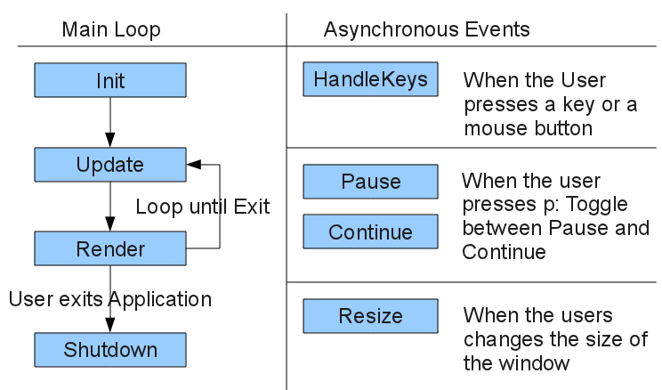
Function | What is it for | When is it called
Void init() | One time initialization of objects, textures etc. | At the very beginning. After OpenGL and Glut initialization before the first update or render call
Void Update() | Change the properties of objects for the next rendering | Before every frame is rendered. Won't be called when in Pause Mode
Void Render() | Execute OpenGL functions (drawing) | Whenever a frame will be displayed on the screen. Won't be called when in pause mode
Void Resize(int NewWidth, int NewHeight) | Adjust size of objects to a new window size | Whenever the size of the window changes. This includes a call when starting up the application
Void HandleKeys(enuKey Code) | React on Keyboard or Mouse Inputs | Whenever a key or a mouse button is pressed
Void Pause() | Stop all animations | When the user request a pause (usually with the p button). Sets the Application in Pause Mode so no more calls to Update or Render
Void Continue() | Continue with the animations | When the users requests to continue with the Applcation. Continues the Application. Update and Render functions are called
Void Shutdown() | Clean up the ressources | At the very end when the application shuts down

Keyboard
Esc | Exit the Application
P | Toggle between Pause and Continue

Fields of the Class
InputManager Input | To register keys to actions and actions to functions
GLShaderManager ShaderManager | -
GLBatch Batch | -
int FrameCounter | Can be used to query in which frame we are
bool PauseFlag | True when we are in Pause Mode, false otherwise

Write an Application
#include "Application/SimpleApplication.h"
class SkeletonApp : public SimpleApplication {
public:
SkeletonApp();
};
SkeletonApp::SkeletonApp() : SimpleApplication("Skeleton", 800, 600) {
}
int main(int argc, char *argv[]) {
SkeletonApp App;
App.Start();
}
You can overwrite any of the Lifecycle methods to do some actions

Handle Keys
The easiest way is to handle all keys in the HandleKeys Lifecycle method:
void SkeletonApp::HandleKeys(enuKey Code) {
if (Code == APP_KEY_ESC) {
exit(0);
}
}

or you can register a key to an action and a function to the action
enuKey Left = APP_KEY_A;
enuKey Right = APP_KEY_D;
enuKey Up = APP_KEY_W;
enuKey Down = APP_KEY_S;
// Register 4 keys for the action Move
Input.AddBinding("Move", Left);
Input.AddBinding("Move", Right);
Input.AddBinding("Move", Up);
Input.AddBinding("Move", Down);
// Define which function will be called for this action
Input.AddListener("Move", this->HandleMoveKeys);

// The function to handle the keys → must be static because it is a function pointer!
static void SimpleApplication::HandleMoveKeys(enuKey Code, int x, int y) {
// we could also go in the instance context:
// reinterpret_cast<SkeletonApp*>(Instance)->HandleMoveKeysInInstance(Code);

if (Code == APP_KEY_D) {
//...
}
}

How to manipulate the Graph
TODO

